**CIT 352 Chapter 3**

Name: Celeste George

Complete all Projects by executing every step in each project. For those steps listed below, follow the specified instruction.

Project 3-1

Step 14

* What would have been the absolute pathname you could have used?

cd /etc/sysconfig/home/user1/Desktop

Project 3-2

Step 10

* Insert the screen capture

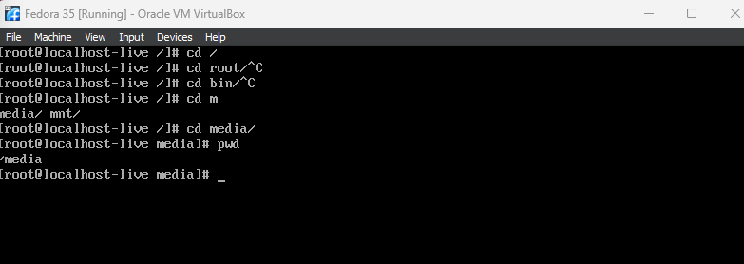

Project 3-3

Step 16

* Insert the screen capture

Project 3-4

Step 10

* Insert the screen capture

Project 3-5

Step 34

* Insert the screen capture

Project 3-6

Step 8

* Insert the screen capture

Project 3-7

Step 15

* Insert the screen capture

**Command Reference** (List all new commands you learned in this chapter)

vi commands

i

o

dd

dw

yy

P

grep

**Discovery Exercises**

Solve the following problems from the textbook under Discovery Exercises. Search the Internet for answers if you don’t know.

2.

a. cd /usr

b. cd /

c. cd /usr/local/share/info

d. cd share/info

e. cd /etc

f. cd ../../etc

3.

a. ls -l /etc/*.cfg

b. ls -a /home/user1

c. ls -l /var

d. ls /bin/[a]*

e. ls /bin/???

f. ls /bin/??[th]